**AIM:** Write a C program to implement the application of Stack (Notations)

**ALGORITHM:**

1. Start with an empty stack and empty postfix string.
2. Scan the infix expression from left to right:
   * If operand → add to postfix.
   * If ( → push to stack.
   * If ) → pop from stack until ( is found.
   * If operator → pop from stack to postfix until lower precedence is found, then push current operator.
3. After scanning → pop remaining operators from stack to postfix.
4. End.

**Postfix Evaluation (using Stack)**

1. Start with an empty stack.
2. Scan postfix expression left to right:
   * If operand → push to stack.
   * If operator → pop 2 elements, apply operator, push result.
3. Final result = element left in stack.
4. End.

**CODE:**

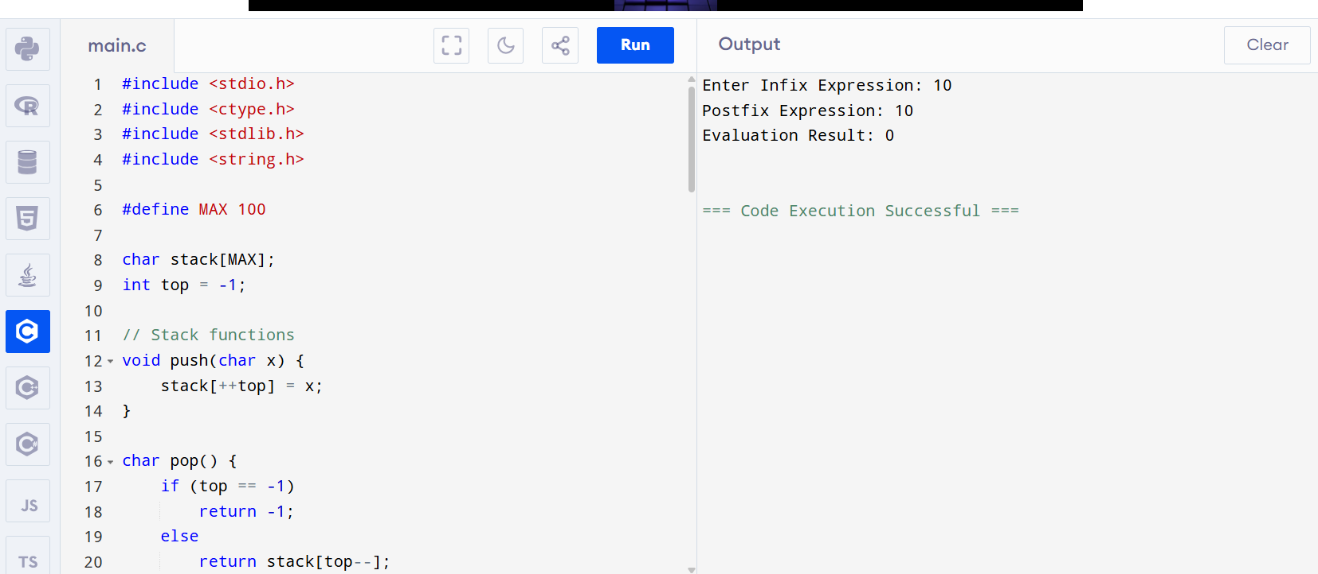

**OUTPUT:**

Enter Infix Expression: 10

Postfix Expression: 10

Evaluation Result: 0

=== Code Execution Successful ===